Head Office: The Old Vicarage Bamber House
Church Lane
Hambleton
Lancashire
FY6 9BZ

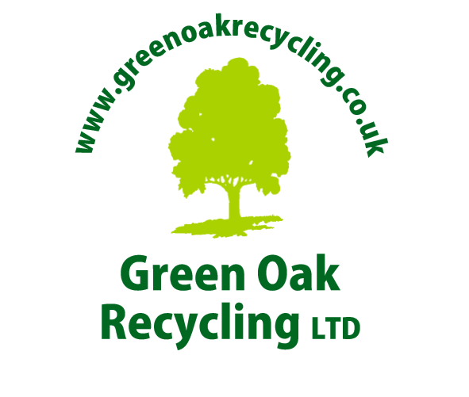
Data Protection Statement

Effective Date: May 25th 2018

Green Oak Recycling Ltd is committed to ensuring that your privacy is protected when personal information about you is provided to us. In this Data Protection Statement reference to “we” or ”us” or “our” shall mean Green Oak Recycling Ltd
Green Oak Recycling Ltd is the data controller of your personal data and is subject to the General Data Protection Regulation (the “GDPR”).
All queries relating to GPDR should be referred to our central point of contact for data queries. Their contact details are:
Email –sales@greenoakrecycling.co.uk Telephone – +44 (0) 1253 883361
This Data Protection Statement explains: your rights; how we collect your data: what personal information we may hold about you; the purposes for which your personal information may be used; and details of third parties to whom your personal information may be disclosed.
This Data Protection Statement supersedes any previous Data Protection Statement or equivalent, which you may have been provided with or seen prior to the Effective Date stated above.
Your rights
Under the GDPR you have the following rights:
- ‣ To obtain access to, and copies of, the personal data that we hold about you;
- ‣ To require that we cease processing your personal data if the processing is causing you damage or distress;
    - ‣ To require us not to send you marketing communications;
- ‣ To require us to erase your personal data;
- ‣ To require us to restrict our data processing activities;
- ‣ To receive from us the personal data we hold about you which you have provided to us, in a reasonable format specified by you, including for the purpose of you transmitting that personal data to another data controller; and
- ‣ To require us to correct the personal data we hold about you if it is incorrect.

Please note that the above rights are not absolute, and we may be entitled to refuse requests where exceptions apply.
You can find out more about your rights at the Information Commissioner’s Office.
If you have any questions about how we use your personal data, or you wish to exercise any of the rights set out above, please contact us using the following:
Email –sales@greenoakrecycling.co.uk Telephone – +44 (0) 1253 883361
We will ensure to take all reasonable steps to keep accurate and up to date any of the information we hold about you. If, at any time, you discover that the information we hold about you is incorrect, you should contact us to have the information corrected.
If you are not satisfied with how we are processing your personal data, you can make a complaint to the Information Commissioner’s Office.

How we collect your data
We collect your personal data in a number of ways, for example:
- ‣ From the information you provide to us when you meet us;
- ‣ From information about you provided to us by your company or an intermediary;
  - ‣ When you communicate with us by telephone, fax, email or other forms of electronic communication. In this respect, we may monitor, record and store any such communication;
- ‣ When you complete (or we complete on your behalf) a Service Agreement, Annual Duty of Care/Waste Transfer Note or any other form we may provide from time to time.
- ‣ From your agents, advisers, intermediaries, and custodians of your assets;
- ‣ From publicly available sources or from third parties, most commonly where we need to conduct background checks about you.

  - The categories of personal data we collect
- We collect the following categories of personal data about you:
- ‣ Your name and contact information such as your current and previous home or business address, email address and telephone number;
- ‣ We may collect your bank account details;
‣ Information to assess whether you may represent a politically exposed person or money laundering risk:
We may also hold information about you which we have received from third parties, such as credit reference agencies, fraud prevention agencies and insurance reference agencies, which may include:-
- ‣ All the types of information mentioned in the previous paragraph;
- ‣ Whether you have any adverse credit history;
- ‣ Whether you have any CCJs or similar judgments against you;
- ‣ Whether you have ever been bankrupt;
- ‣ Details of previous address at which you have lived;
- ‣ Details of insurance claims you have made;

The basis for processing your personal data (other than with your consent), how we use that personal data and whom we share it with

- (1) Performance of contract
- We process your personal data because it is necessary for the performance of a agreement to which you are a party or in order to take steps at your request prior to entering into a agreement. In this respect, we use your personal data for the following:
- ‣ To prepare a Service Agreement for you regarding the services we offer;
- ‣ To provide you with the services as detailed in the Service Agreement which we and you agreed to and signed;
- ‣ To deal with any complaints or feedback you may have;
- ‣ For any other purpose for which you provide us with your personal data.
- In this respect we will share your personal data with the following:
‣ Your agents, advisers, intermediaries, and custodians of your assets who you tell us about;
‣ Our legal, accounting, marketing or other professional advisers, our postal or transport providers;
- ‣ Credit reference agencies and fraud prevention agencies;
- ‣ Other agencies who maintain/compile databases of insurance claims and information for the purposes of sharing that information with providers of credit and insurance (“Insurance Reference Agencies”);
- ‣ Insurers and/or insurance agents;
- ‣ Third parties for the purpose of such persons giving us a reference about you;
- ‣ Third parties whom we engage to assist in delivering the services to you;
- ‣ Our data storage providers
- (2) Legitimate interests
    - We also process your personal data because it is necessary for our legitimate interests, or some- times where it is necessary for the legitimate interests of another person.
    - In this respect, we use your personal data for the following:
- ‣ For the administration and management of our business, including recovering money you owe to us and our clients and archiving or statistical analysis;
- ‣ Seeking advice on our rights and obligations;
- In this respect we will share your personal data with the following:
    - ‣ Our advisers or agents where it is necessary for us to obtain their advice or assistance;

(3) Legal obligations
- We also process your personal data for our compliance with a legal obligation which we are under.
- In this respect, we will use your personal data for the following:
- ‣ To meet our compliance and regulatory obligations, such as compliance with anti-money laundering laws;
- ‣ As required by tax authorities or any competent court or legal authority.
- ‣ As required by a local authority or other appropriate body in regard any occupational obligation under statute.
- In this respect, we will share your personal data with the following:
‣ Our advisers where it is necessary for us to obtain their advice or assistance;
- ‣ Our auditors where it is necessary as part of their auditing functions;
- ‣ With third parties who assist us in conducting background checks;

‣ With relevant regulators or law enforcement agencies where we are required to do so;

- Where we need your explicit consent to communicate with you
We will in certain cases communicate with you provided that you have given your explicit consent as set out below:
It should be noted that if you do not agree to this or you withdraw your consent then this may impact the scope of the services we are able to provide to you on an ongoing basis.
Withdrawal of Consent
If you have given your consent and you wish to withdraw it at any time, please contact us using the following:
Email – sales@greenoakrecycling.co.uk Telephone – +44 (0) 1253 883361

Transfer and processing of your personal data outside the European Union
When sharing your personal data with third parties as set out in this Privacy Notice, it may be transferred outside the European Union. In these circumstances, your personal data will only be transferred on one of the following bases:
- ‣ The country that we send the personal data to is approved by the European Commission as pro-viding an adequate level of protection for personal data;
- ‣ The transfer is to a recipient in the United States of America who has registered under the EU/ US Privacy Shield;
‣ The recipient has entered into European Commission standard contractual clauses with us;
Or you have explicitly consented to the same prior to the transfer of any personal data.

To find out more about transfers by us of your personal data outside the European Union and the countries concerned please contact us using the following:
Email – sales@greenoakrecycling.co.uk Telephone – +44 (0) 1253 883361

Retention of your data
We will only retain your personal data for as long as we have a lawful reason to do so. In particular:
- ‣ Where we have collected your personal data for the purpose of a Service Agreement between ourselves, we will retain that personal data for ten years after the termination of that agreement, unless we are required to retain this information by another law or for the purposes of court proceedings;
- ‣ Where we have collected your personal data as required by anti-money laundering legislation, including for identification, screening and reporting, we will retain that personal data for ten years after the termination of the Service Agreement, unless we are required to retain this information by another law or for the purposes of court proceedings;
- ‣ We will in most cases retain your personal data for a period of ten years after the termination your Service Agreement in case any claims arise out of the provision of our services to you.

Managing Director
Green Oak Recycling Ltd

